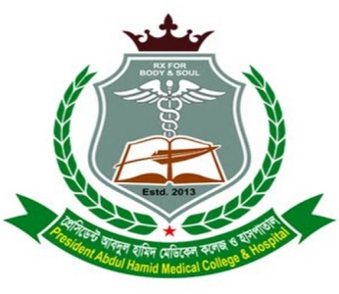
‡cÖwm‡W›U Ave`yj nvwg` †gwW‡Kj K‡jR
(Avãyj nvwjg Lvb dvD‡Ûkb cwiPvwjZ)
Wv³vievox, Rvdivev`, KwigMÄ,
wK‡kviMÄ, evsjv‡`k
President Abdul Hamid Medical College
(Organized & directed by Abdul Halim Khan Foundation)
Daktarbari, Jafrabad, Karimganj, Kishoreganj, Bangladesh
Cell # 01711 681660, 01678 321001
e-mail: pahmch@gmail.com

Date: 10 January 2024
To Whom It May Concern
I am pleased to write a recommendation letter for Mr. Mohammad Nayeem Hasan, whom I have known for approximately five years as a dedicated co-worker in various research endeavors. Mr. Hasan is a bright, energetic, compassionate, and well-rounded individual, well-prepared for advanced graduate studies.
During our collaboration, Mr. Hasan demonstrated exceptional talent and was a standout team member. We both published more than 10 research papers in some reputed journals. Notably, he contributed significantly to a publication titled "Association of household fuel with acute respiratory infection (ARI) under-five years children in Bangladesh" which was published in Frontiers in Public Health. He also contributed significantly to "Wastewater-based epidemiological surveillance to monitor the prevalence of SARS-CoV-2 in developing countries with onsite sanitation facilities" which was published in Science of the Total Environment. We also collaborated on numerous other projects, and I observed his enthusiasm for acquiring in-depth knowledge related to our field. Mr. Hasan exhibited exceptional intelligence, diligence, sincerity, and the ability to make independent judgments. His problem-solving skills, including defining issues clearly, identifying relevant factors and relationships, and formulating testable hypotheses through statistical data analysis, were truly impressive. His dedication to conducting research using available resources is highly commendable.
Mr. Hasan's positive demeanor and effective interactions with both junior researchers and colleagues underscore his excellent interpersonal skills. Furthermore, his contributions to enhancing research facilities within his designated area are noteworthy. He consistently displays discipline, sincerity, and a cooperative approach in all his endeavors. His proficiency in English further strengthens his ability to communicate effectively.
Based on Mr. Hasan's outstanding track record and current performance, I wholeheartedly recommend him for admission and scholarship opportunities. I am confident that he will excel in any academic or professional pursuit he chooses to undertake.

Sincerely,

Md. Aminul Islam
Lecturer, Department of Microbiology
President Abdul Hamid Medical College Hospital, Kishoreganj (PAHMCH)
Head and Lab In charge, Advance Molecular Lab, PAHMCH
Phone/whats app: +8801734452665
E-mail: aminul@pahmc.edu.bd

